GASD Record of Outside Food Form
(Food meant for sharing with students ONLY)
Eat Smart Nutrition Standards Checklist:
Standards for Snacks and Beverages will comply with the USDA Competitive Food Regulations, The Healthy Hunger Free Kids Act, Section 208; and New York State Education Department, Article 19.915 Prohibiting the Sale of Certain Sweetened Food. | YES | NO
Snack Foods
Food Label containing the Ingredient Statement and Expiration Date attached to this form. (If the answer is NO, product should not be accepted)
Product is a whole-grain rich product or have whole grains as the first ingredient.
Product does not contain more than 10% of total calories from saturated fats = [(grams of sat. fat X 9) / total calories] x 100
35% or Less Sugar Grams by weight = [g sugar/total gram weight of package] x 100
Sodium content of 200 mg or less for all snacks
No more than 200 calories for snacks
Trans fat = 0 grams/serving
Exempt: Nuts, Seeds, Dried Fruit with no added sweeteners or fats, reduced fat cheese
Beverages:
Carbonated Beverages (Not Allowed)
100% Juice Fruit or Vegetable: 8oz or Less Elementary School / 12oz or Less Middle/High School
High School ONLY: “Low calorie” beverages 12oz or Less that contain 40 calories or Less per 8oz or 60 calories or Less per 12oz.
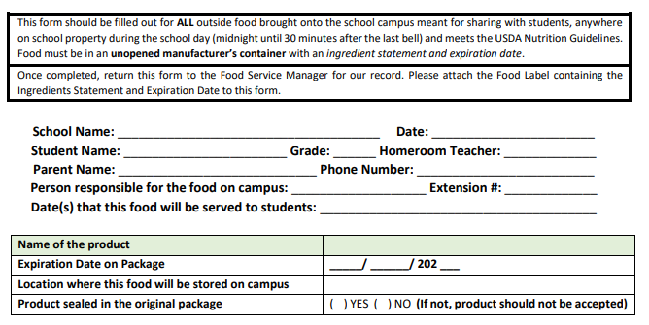

*Use the Smart Snack Calculator to help you determine if the product meets nutrition standards. https://foodplanner.healthiergeneration.org/calculator/

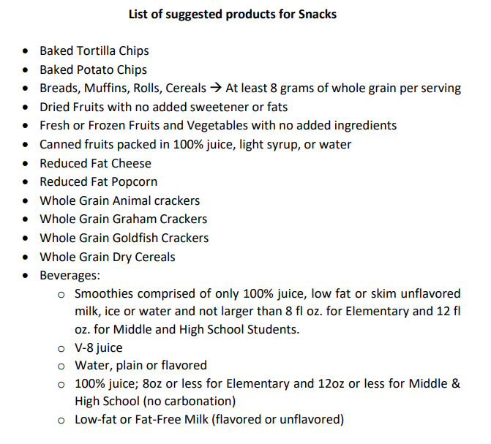

*Coordinate with your School Food Service Director to learn more about Classroom Celebrations available to purchase as Smart Snack approved celebrations*

